Practical - 6

Practical Title: Rendering External JSON Data using Fetch API, Search and Filter

Problem Definition: Display event lists, student profiles, notices, or FAQs from external JSON
files using Fetch API. Implement dynamic rendering, search, filter,
sorting, and pagination.

Theory:
1. How is JSON fetched, parsed, and rendered?
JSON data is fetched from external JSON files (events.json, students.json, and faqs.json) using the JavaScript Fetch API. The response is converted into JavaScript data using response.json(). The data is then dynamically displayed on the webpage using DOM manipulation and methods such as createElement() and appendChild().
2. Which array methods are used for search, filter, sort, and pagination?
The filter() method is used to search records and filter them by category or course. The sort() method arranges records alphabetically or by date. The slice() method is used for pagination to display a limited number of records per page, while map() helps render the records dynamically.
3. How are loading and error states handled?
A loading message is displayed while JSON data is being fetched. The try...catch block and response status check handle fetching errors. If a JSON file cannot be loaded, an appropriate error message is displayed instead of leaving the page blank.
4. How is modularity maintained in JavaScript files?
Modularity is maintained by using separate JavaScript files—events.js, students.js, and faqs.js—for the respective datasets. Each file handles fetching, searching, filtering, sorting, pagination, and rendering its own data, making the code easier to organize, understand, and maintain.

- Implementation/ Output/Result
https://github.com/margiruparel2907-collab/webdev/tree/master/Prac_6

- Evidence of Work (Screenshots)
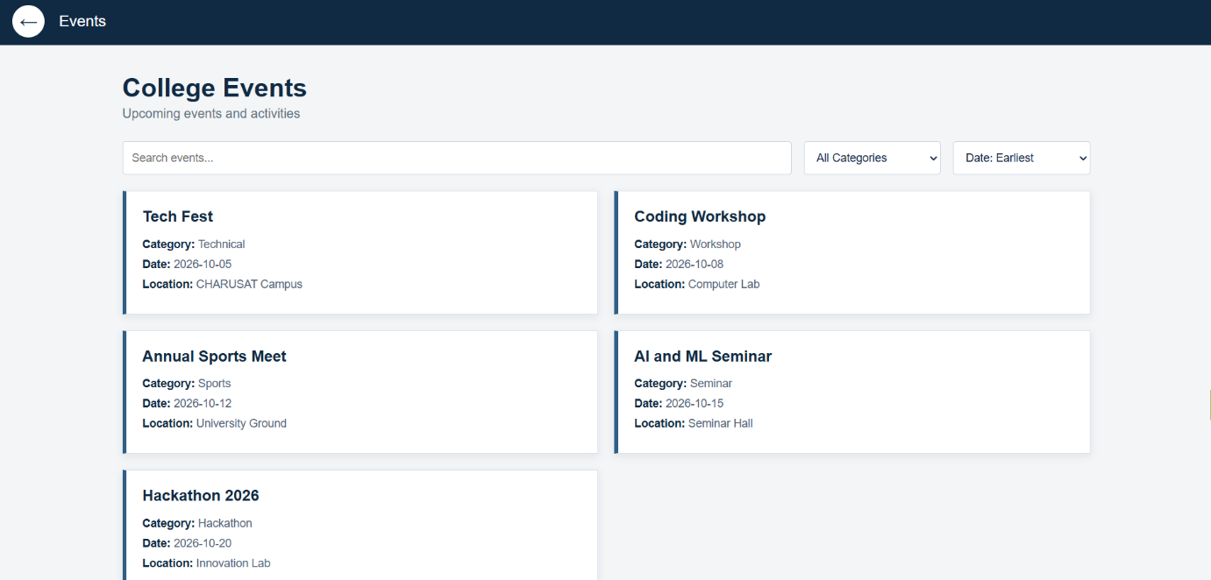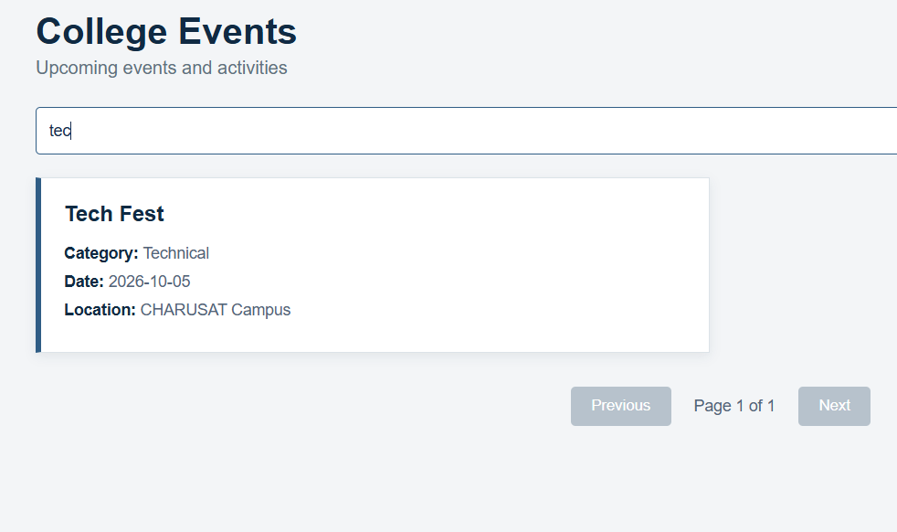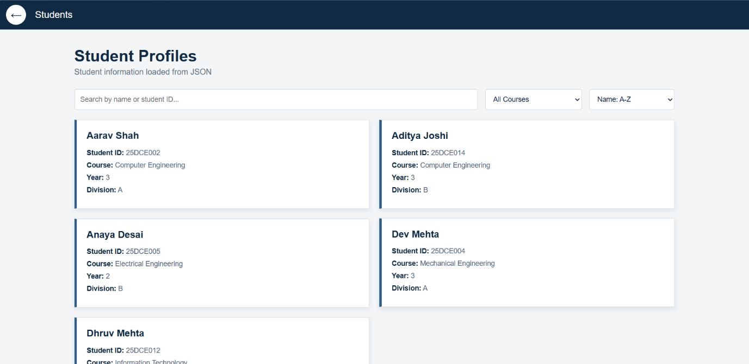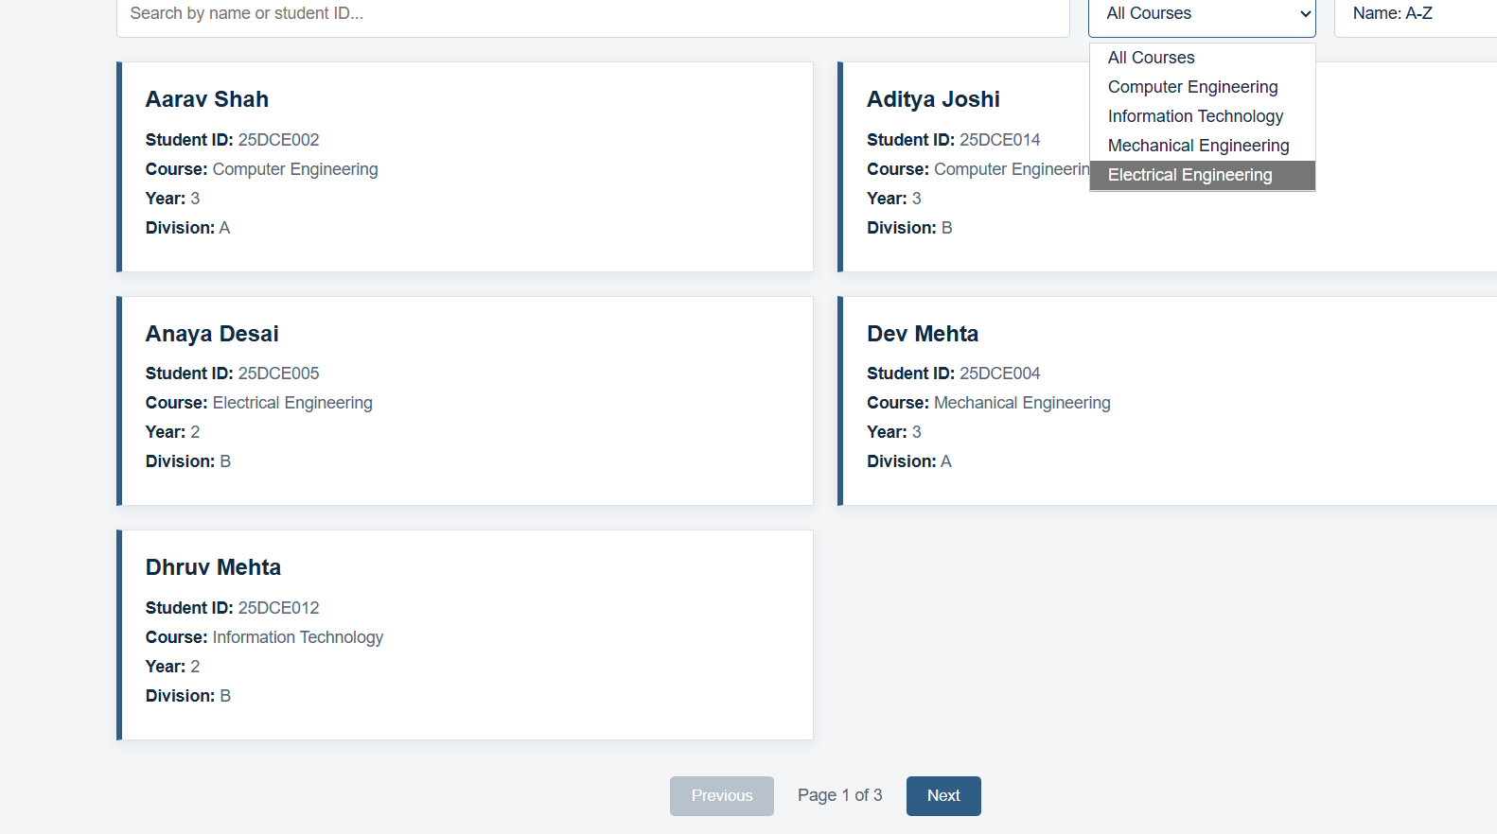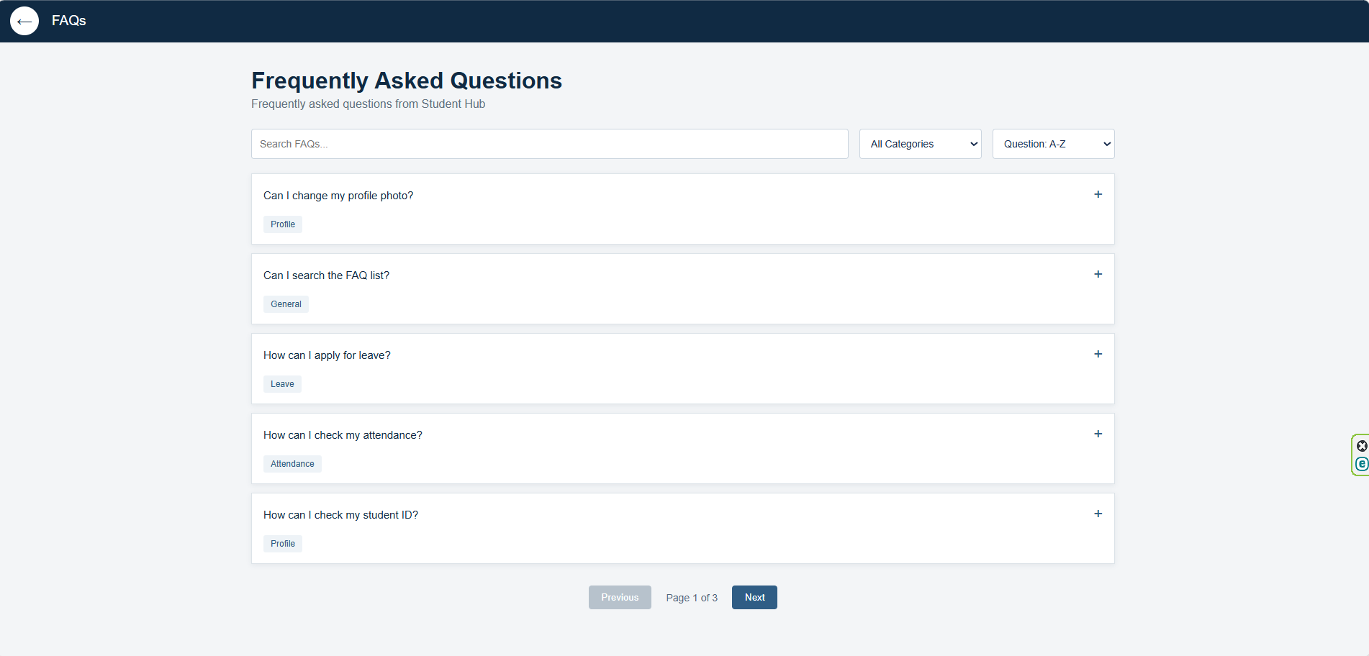

- GitHub Repository Link:
https://github.com/margiruparel2907-collab/webdev

- Challenges Faced:
During this practical, the main challenges were fetching JSON data correctly, converting it into usable JavaScript objects, and displaying the records dynamically instead of writing them directly in HTML. Implementing search, filtering, sorting, and pagination together required careful handling of arrays and the current page number. Another challenge was handling loading and error states when data could not be fetched. These challenges were addressed using the Fetch API, array methods such as filter(), sort(), and slice(), DOM manipulation, and separate JavaScript files for modularity.
- Learning Outcomes:
Through this practical, I learned how to fetch and parse JSON data using the Fetch API and dynamically display it on webpages. I gained practical experience with JavaScript array methods such as map(), filter(), sort(), and slice() for rendering, searching, filtering, sorting, and pagination. I also learned to handle loading and error states, organize code into separate JavaScript files, and test dynamic functionality using browser developer tools. This practical improved my understanding of how modern web applications display and manage external data.

Faculty Remarks: (Keep this blank for faculty)

